Parametric Equations- Questions
June 2018 Mathematics Advanced Paper 1: Pure Mathematics 1

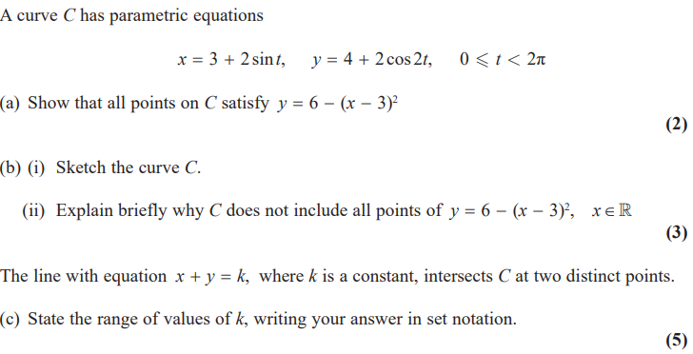

June 2017 Mathematics Advanced Paper 1: Pure Mathematics 4

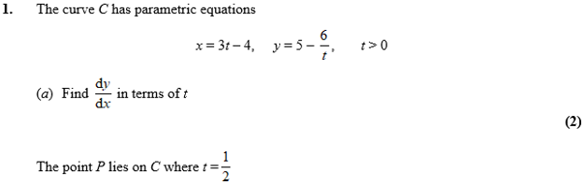
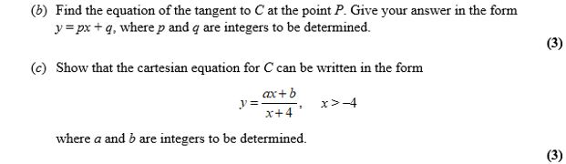

June 2016 Mathematics Advanced Paper 1: Pure Mathematics 4

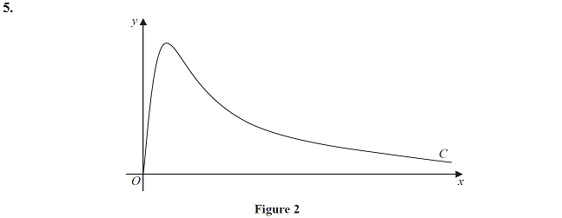
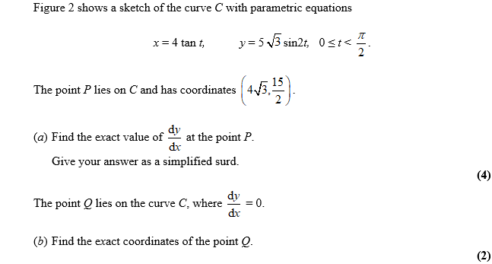
June 2015 Mathematics Advanced Paper 1: Pure Mathematics 4

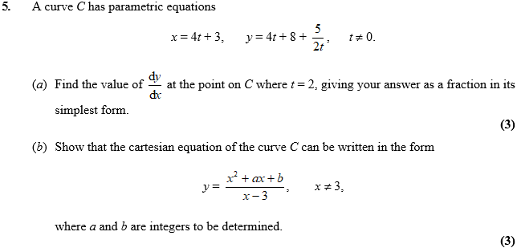

June 2014 Mathematics Advanced Paper 1: Pure Mathematics 4

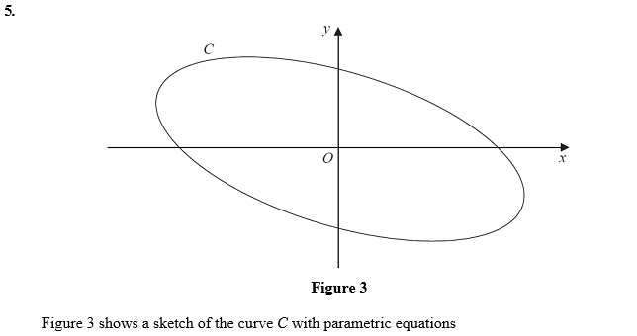
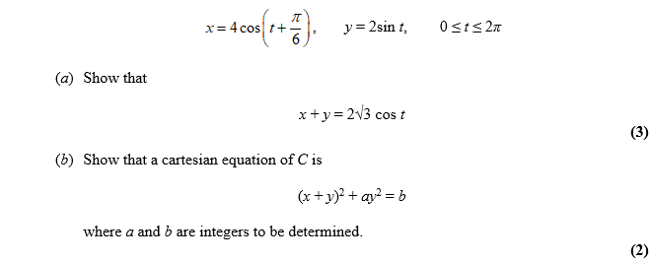

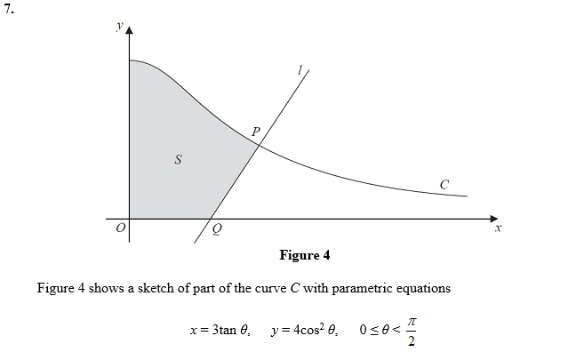
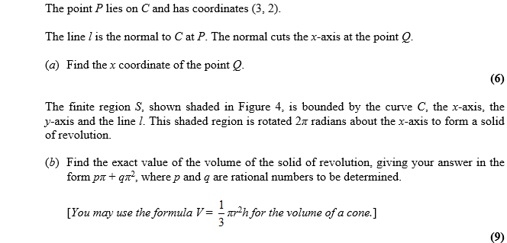

June 2013 Mathematics Advanced Paper 1: Pure Mathematics 4

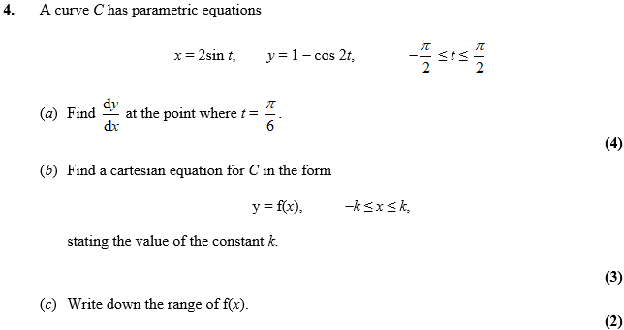

Jan 2013 Mathematics Advanced Paper 1: Pure Mathematics 4

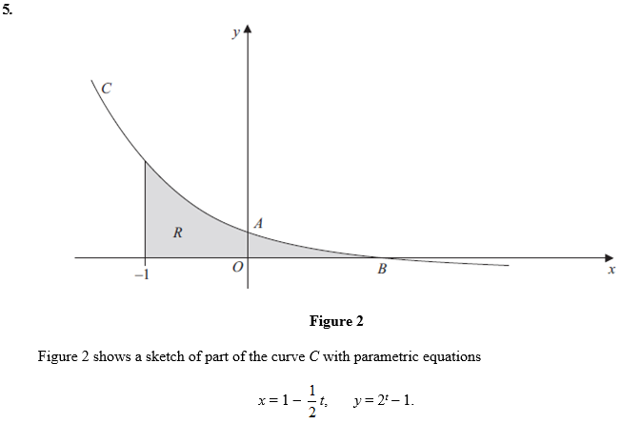
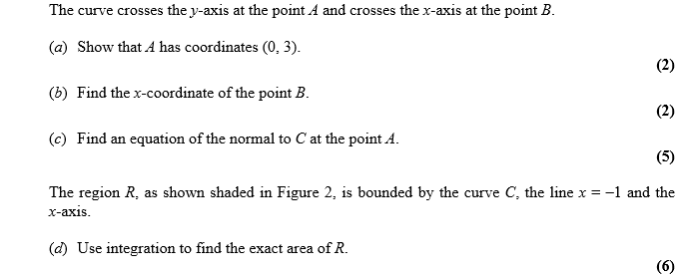

June 2012 Mathematics Advanced Paper 1: Pure Mathematics 4

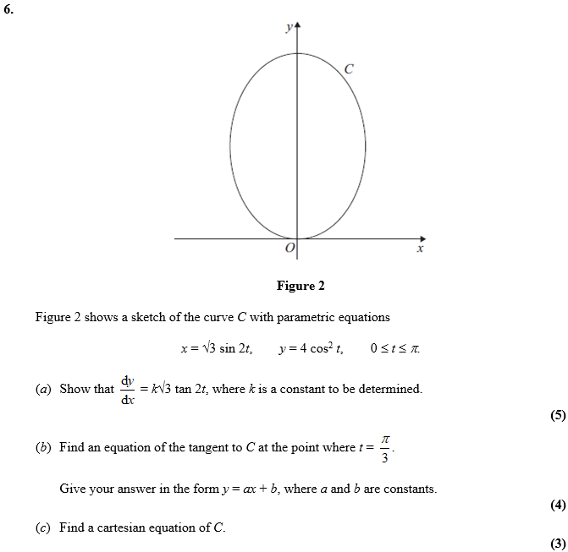

Jan 2012 Mathematics Advanced Paper 1: Pure Mathematics 4

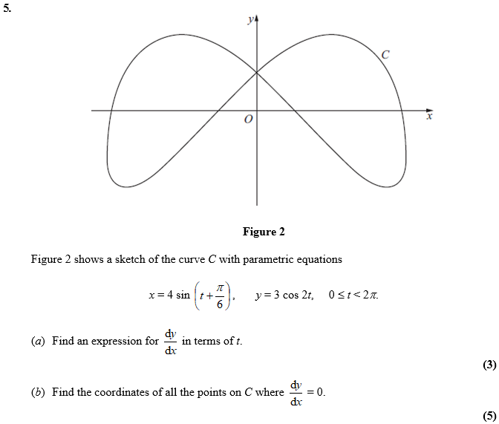

June 2011 Mathematics Advanced Paper 1: Pure Mathematics 4

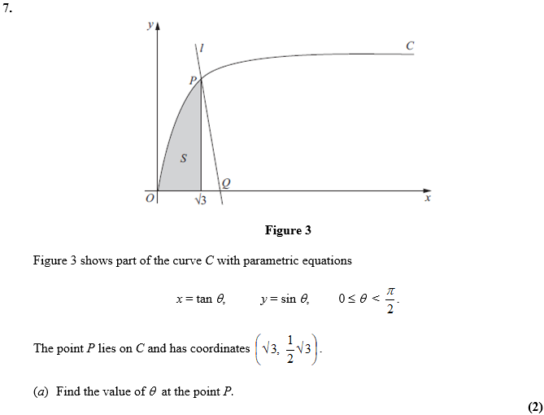
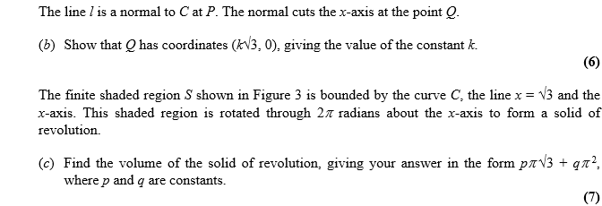

Jan 2011 Mathematics Advanced Paper 1: Pure Mathematics 4

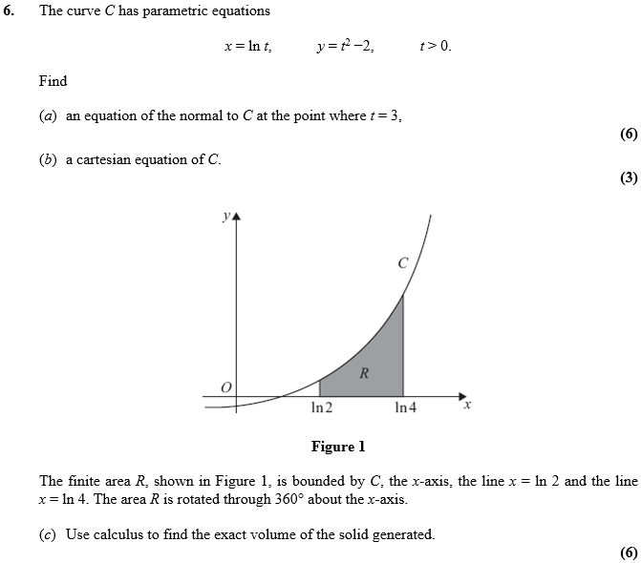

June 2010 Mathematics Advanced Paper 1: Pure Mathematics 4

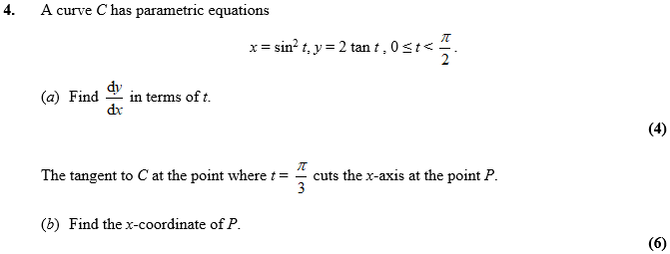

Jan 2010 Mathematics Advanced Paper 1: Pure Mathematics 4

